**DAILY ONLINE ACTIVITIES SUMMARY**

|  |  |  |  |  |  |  |  |
| --- | --- | --- | --- | --- | --- | --- | --- |
| **Date:** | **15/06/2020** | | | | **Name:** | **Churashma** | |
| **Sem & Sec** | **4th SEM 'A' Section** | | | | **USN:** | **4AL18CS019** | |
| **Online Test Summary** | | | | | | | |
| **Subject** | | **No test** | | | | | |
| **Max. Marks** | | **-** | | **Score** | | **-** | |
| **Certification Course Summary** | | | | | | | |
| **Course** | **Introduction to neural networks and deep learning.** | | | | | | |
| **Certificate Provider** | | | **greatlearning academy** | **Duration** | | | **9.5 hours** |
| **Coding Challenges** | | | | | | | |
| **Problem statement 1: Write a C Program to implement the Binary Reversal.**  **Problem statement 2: Write a C Program to perform the following operations on Triply Linked List (TLL).**  **Problem statement 3: Write a Java Program to find if string is K-Palindrome or not.** | | | | | | | |
| **Status: completed** | | | | | | | |
| **Uploaded the report in Github** | | | | **yes** | | | |
| **If yes Repository name** | | | | **https://github.com/Churashma/Lockdown-coding** | | | |
| **Uploaded the report in slack** | | | | **yes** | | | |

ONLINE TEST DETAILS: No test.

COURSE DETAILS: Today I studied about linear regression on Boston housing prices and also I studied about Introduction to Keras.The Boston housing data was collected in 1978 and each of the 506 entries represent aggregated data about 14 features for homes from various suburbs in Boston, Massachusetts. Keras is a high-level neural networks API, capable of running on top of Tensorflow, Theano, and CNTK. It enables fast experimentation through a high level, user-friendly, modular and extensible API. Keras can also be run on both CPU and GPU.

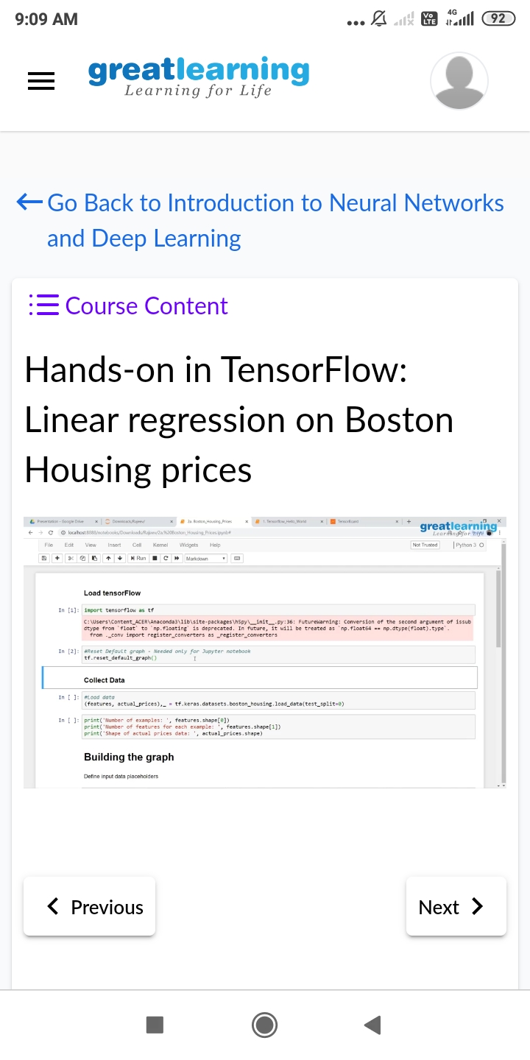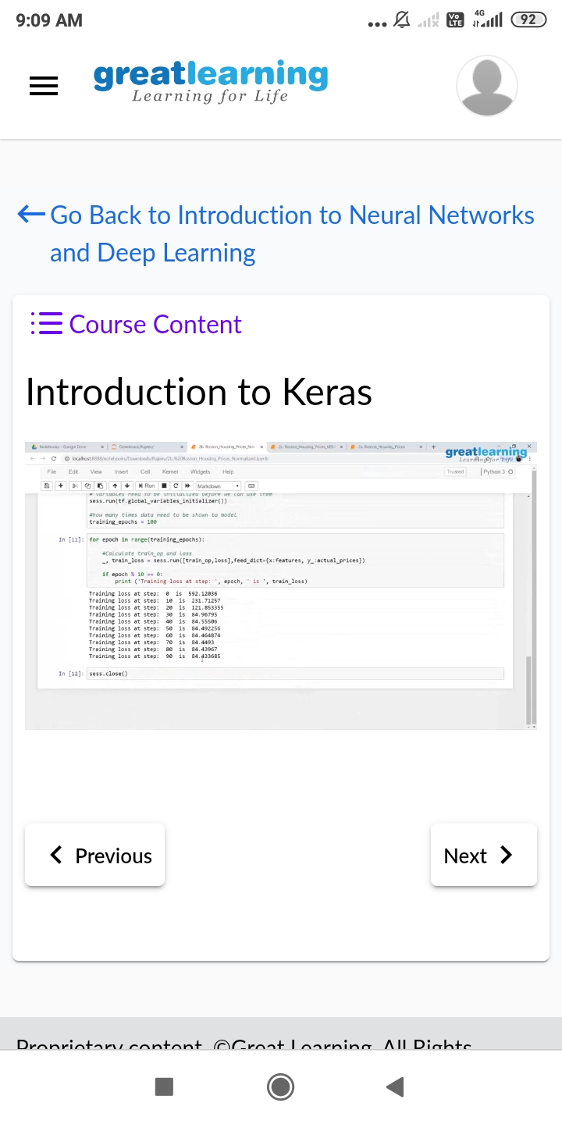

**CODING CHALLENGES DETAILS**:

**Problem statement 1:** Write a C Program to implement the Binary Reversal.

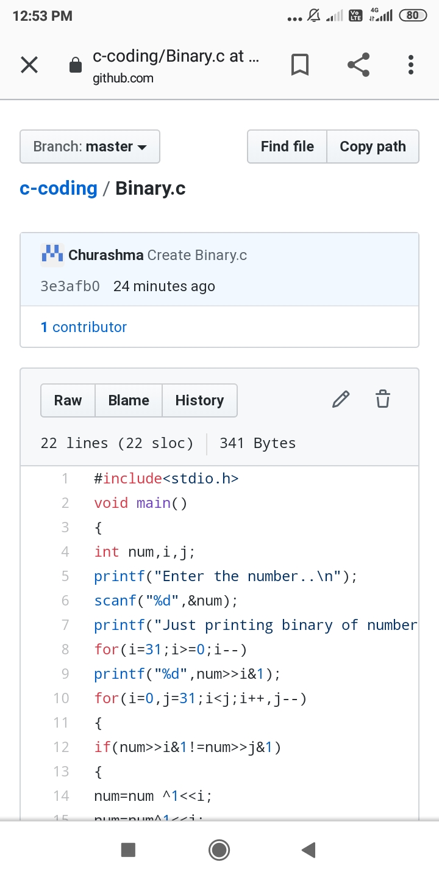

Problem statement 2: Write a C Program to perform the following operations on Triply Linked List (TLL).

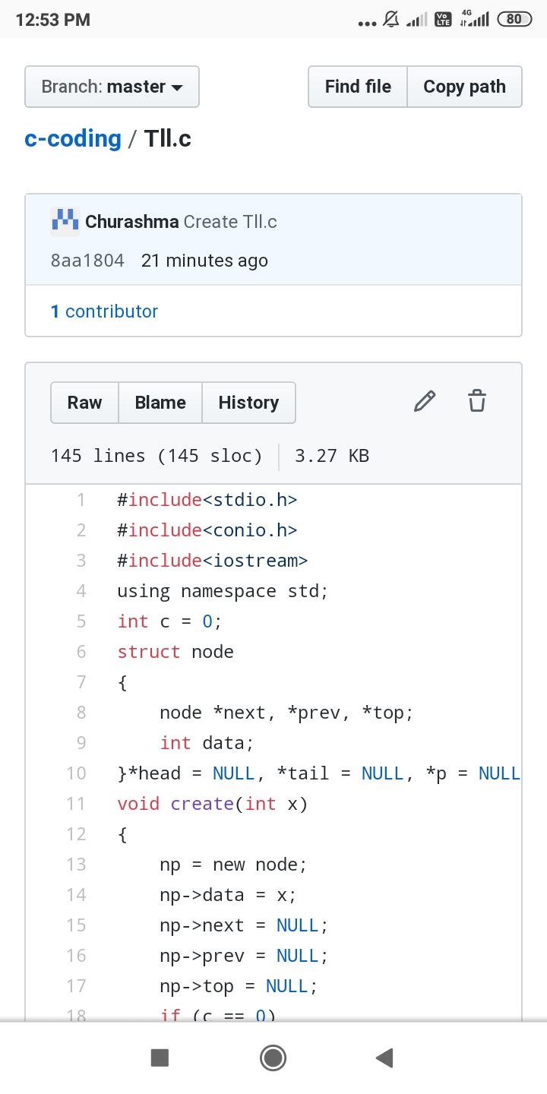

Problem statement 3: Write a Java Program to find if string is K-Palindrome or not.

